Conversion Factors-Answers
Key Stage 3: 2003 Paper 1 Level 3-5
1.
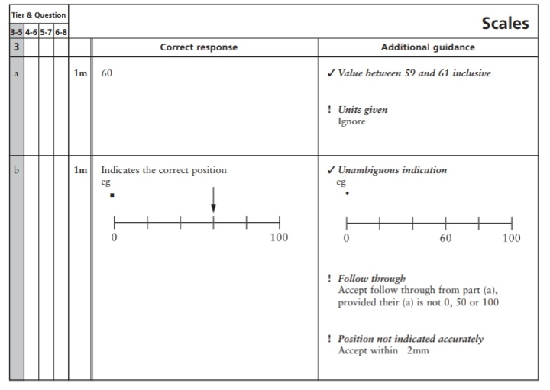

Key Stage 3: 2003 Paper 2 Level 3-5
2.
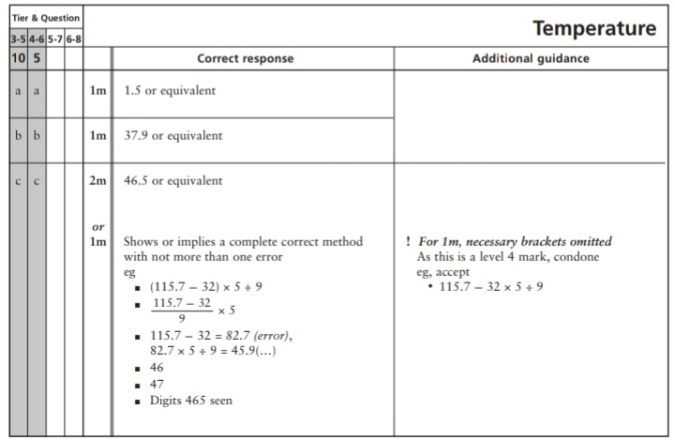
3.
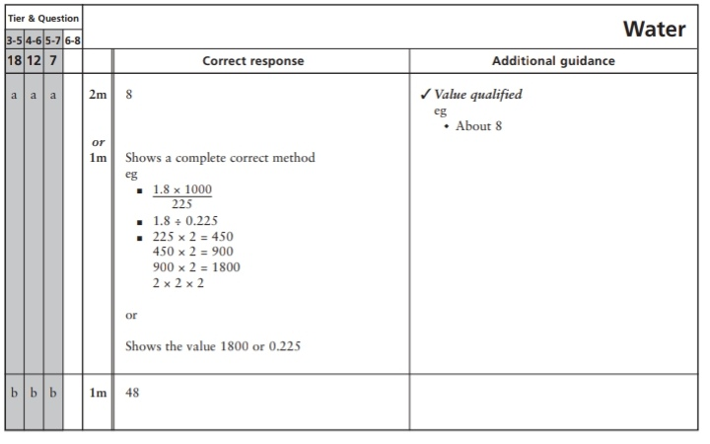
Key Stage 3: 2003 Paper 4-6
4.
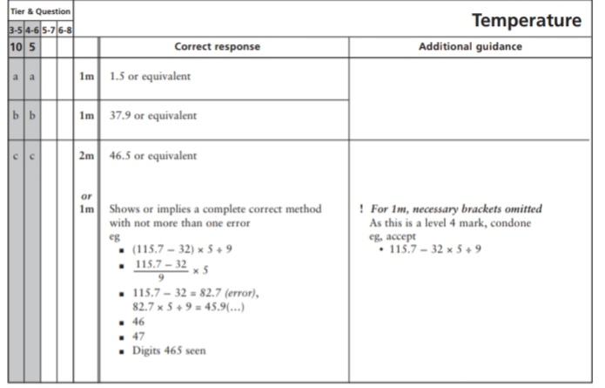
5.
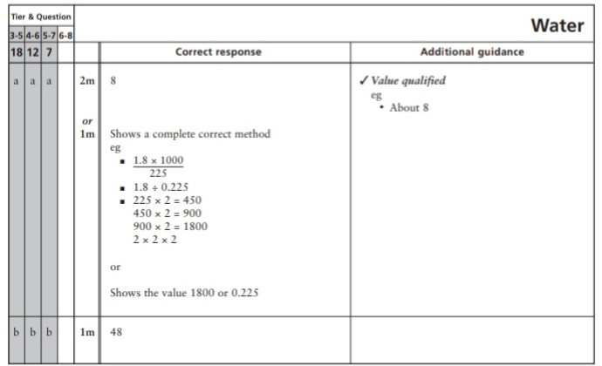
Key Stage 3: 2004 Paper 1 Level 3-5
6.
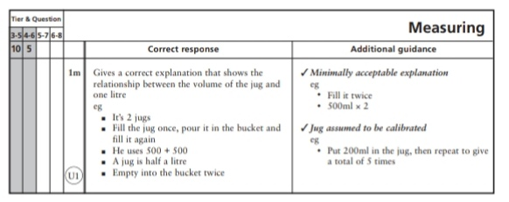
Key Stage 3: 2004 Paper 2 Level 3-5
7.
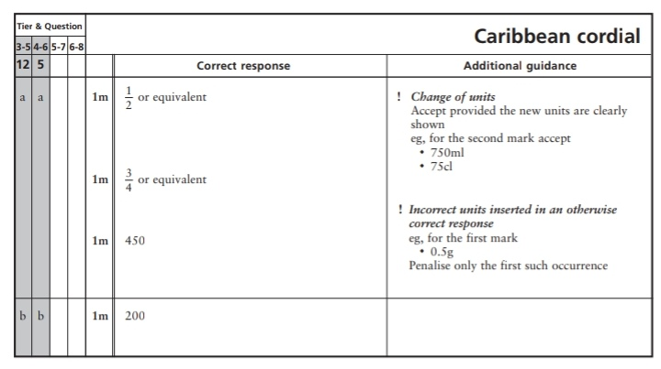
8.
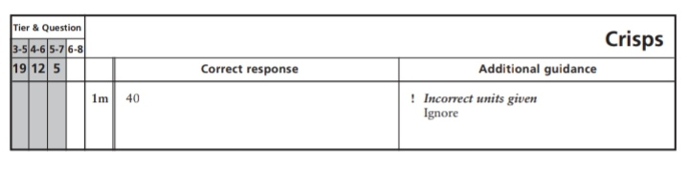
Key Stage 3: 2004 Paper 1 Level 4-6
9.
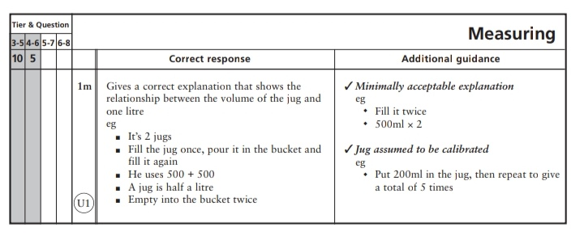
Key Stage 3: 2004 Paper 2 Level 4-6
10.
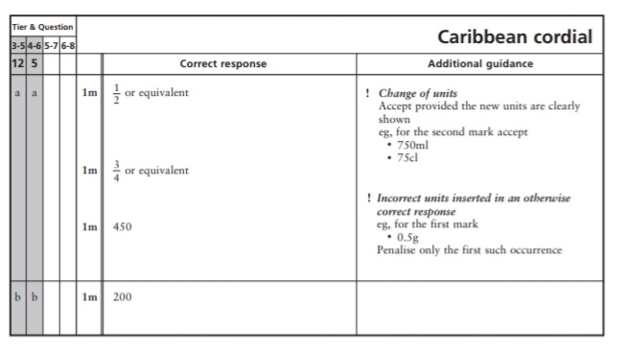
11.
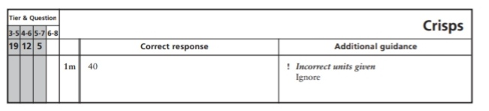
Key Stage 3: 2005 Paper 1 Level 3-5
12.
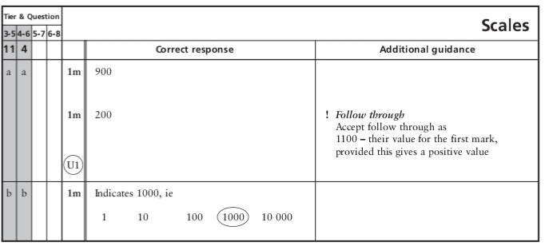
Key Stage 3: 2005 Paper 1 Level 4-6
13.
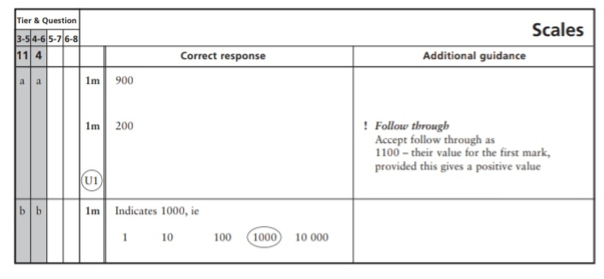
Key Stage 3: 2005 Paper 2 Level 4-6
14.
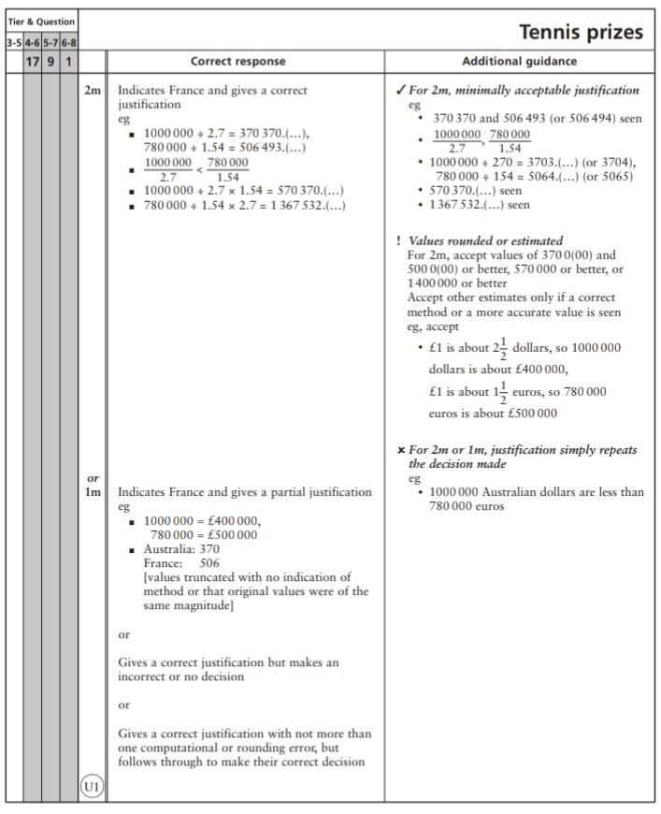
Key Stage 3: 2006 Paper 2 Level 3-5
15.
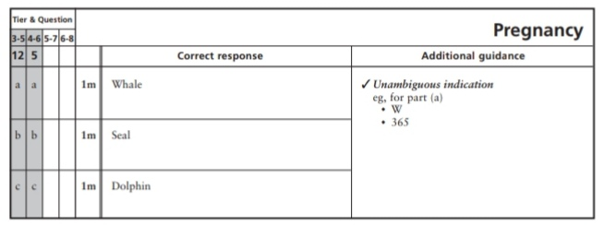
16.
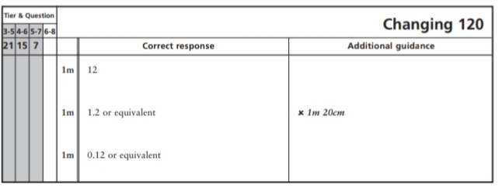
Key Stage 3: 2006 Paper 2 Level 4-6
17.
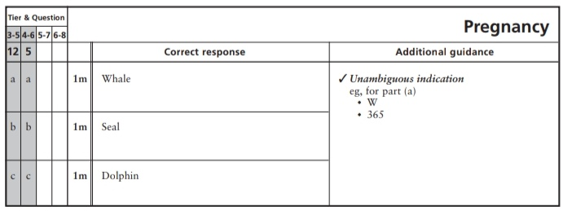
18.
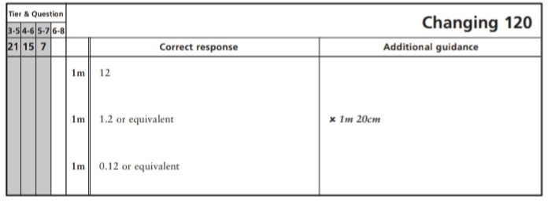
Key Stage 3: 2007 Paper 1 Level 3-5
19.
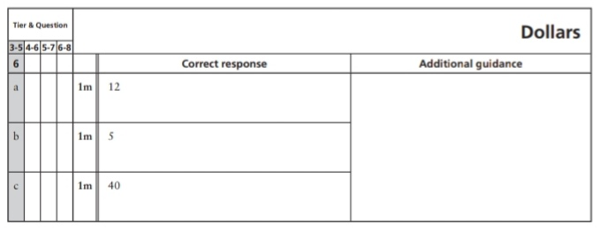
Key Stage 3: 2007 Paper 2 Level 3-5
20.
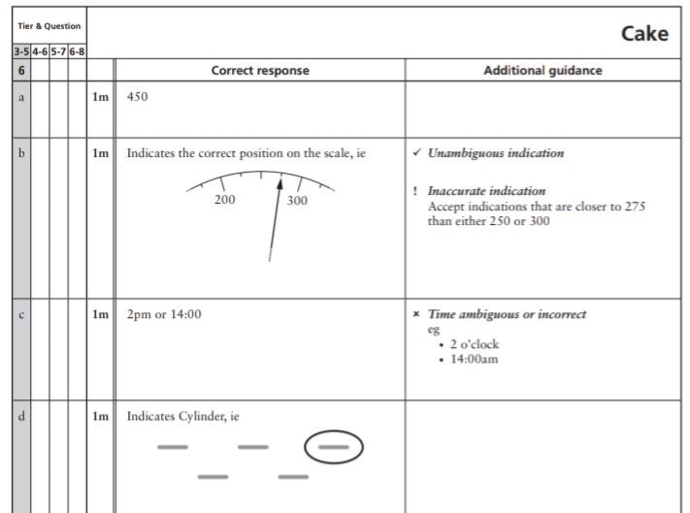
21.
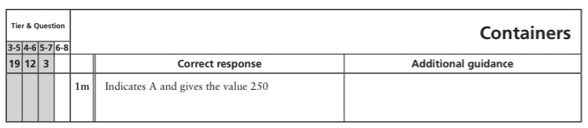
Key Stage 3: 2007 Paper 2 Level 4-6
22.
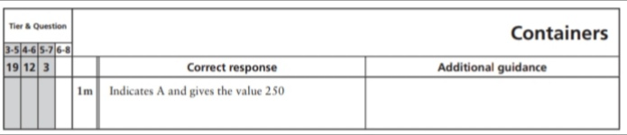
Key Stage 3: 2008 Paper 2 Level 3-5
23.
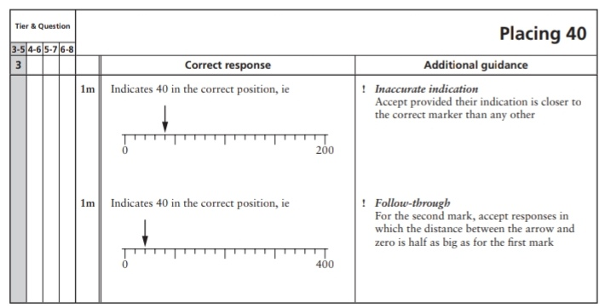
24.
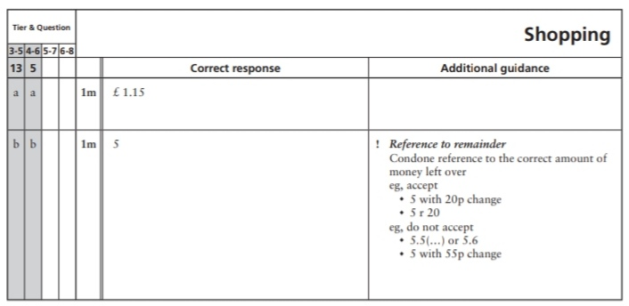
25.
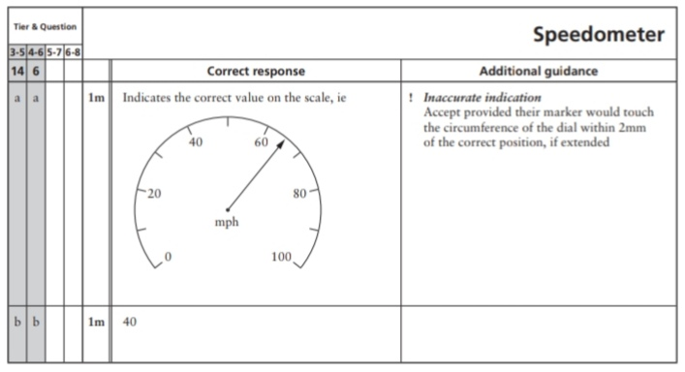
26.
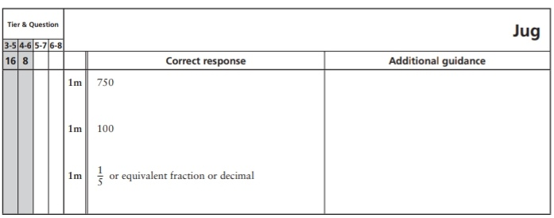
27.
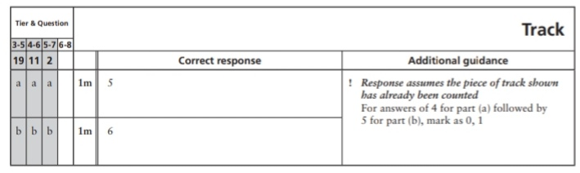
Key Stage 3: 2008 Paper 2 Level 4-6
28.
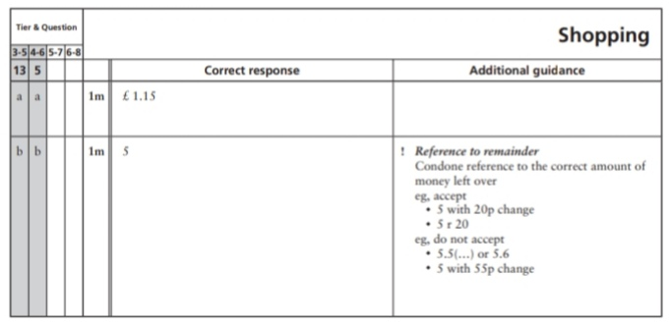
29.
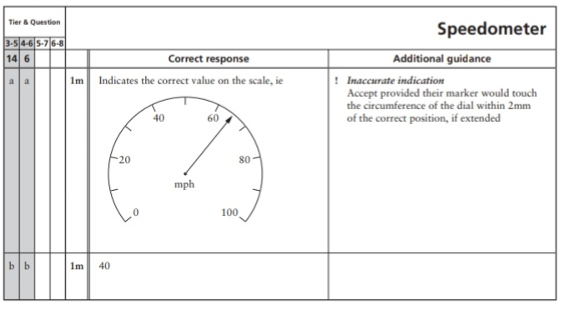
30.
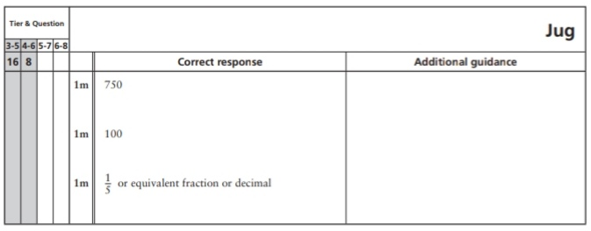
31.
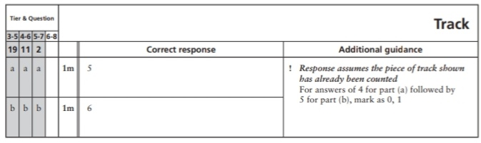
32.
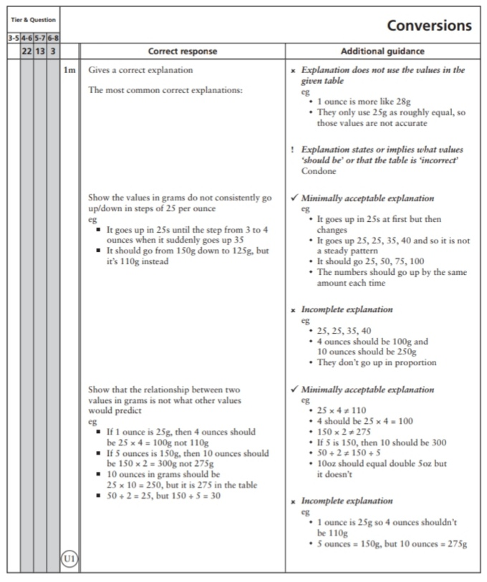
33.
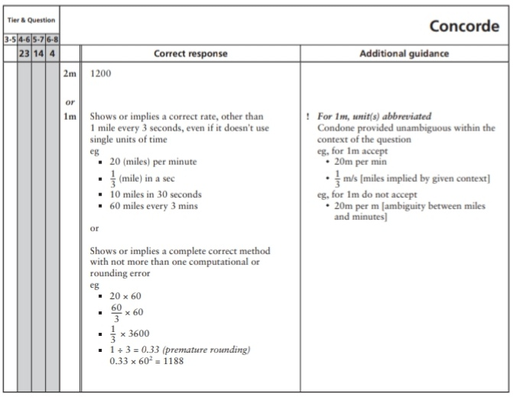
Key Stage 3: 2009 Paper 1 Level 3-5
34.
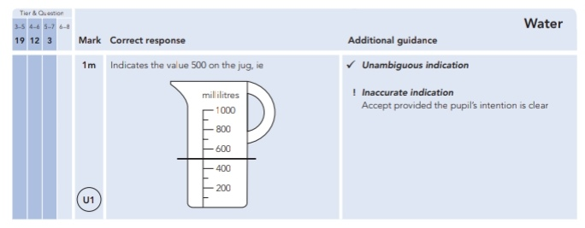
35.
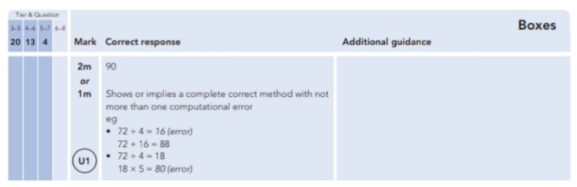
Key Stage 3: 2009 Paper 2 Level 3-5
36.
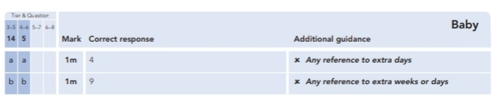
37.
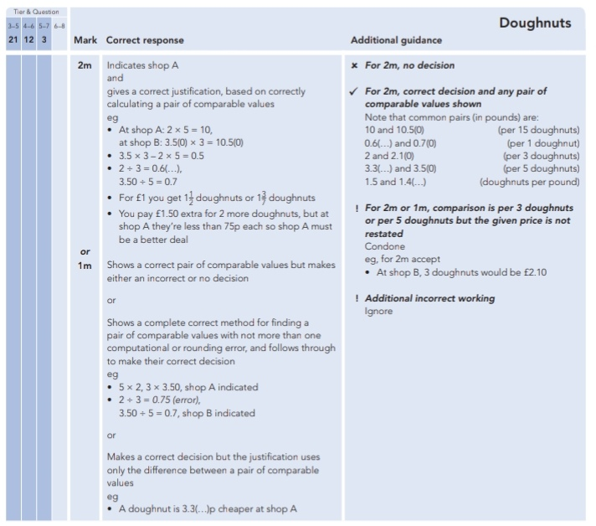
38.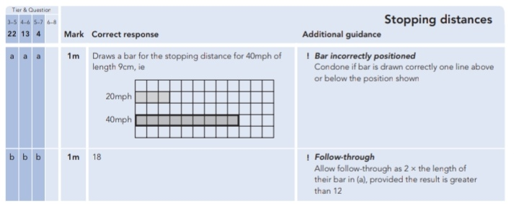
Key Stage 3: 2009 Paper 1 Level 4-6
39.
40.
Key Stage 3: 2009 Paper 2 Level 4-6
41.
42.
43.
Key Stage 3: 2010 Paper 1 Level 3-5
44.
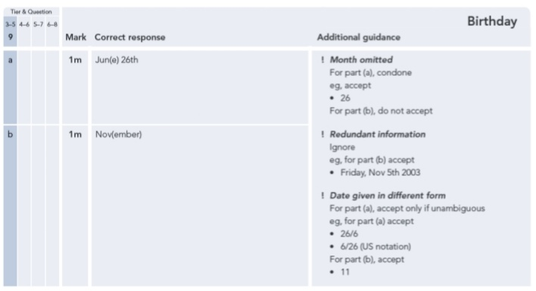
45.
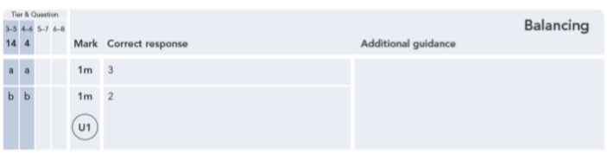
46.
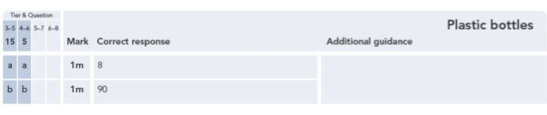
47.
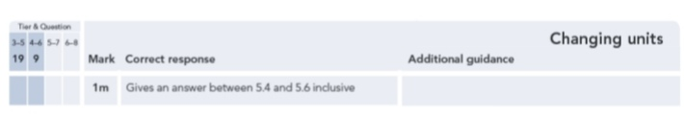
Key Stage 3: 2010 Paper 1 Level 4-6
48.
49.
50.
Key Stage 3: 2010 Paper 2 Level 4-6
51.
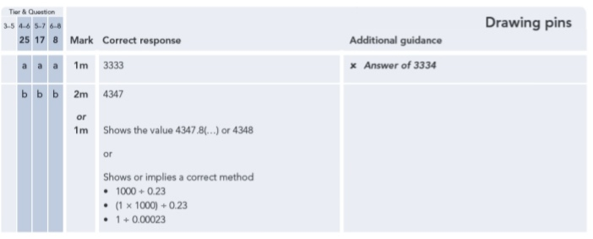
52.
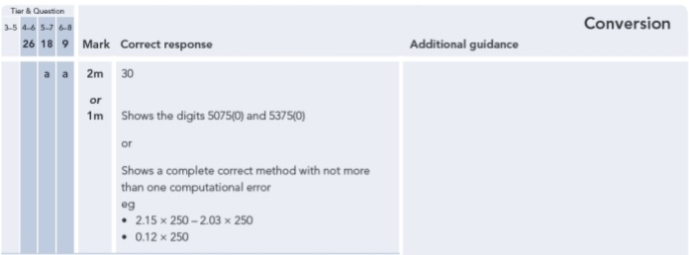
Key Stage 3: 2011 Paper 1 Level 4-6
53.
